WEEK 3
Ames Housing Dataset
Cleaning & Descriptive Report
Before-and-after data quality review

Data source: AmesHousing_Uncleaned.xlsx
Cleaned comparison: AmesHousing_Cleaned(1).csv
Week 3 focus: missing values, duplicates, outliers, and cleaning decisions

1. Executive Summary
Week 3 focused on preparing the Ames Housing dataset for reliable exploratory analysis. The work began with an inspection of the original dataset, followed by an assessment of missing values and unusual observations. The supplied cleaned dataset was then compared directly with the original file to document the observable before-and-after changes.
The original dataset contained 3,130 rows and 82 columns. The supplied cleaned CSV contains 2,930 rows and the same 82 columns. Missing cells decreased from 17,010 to 15,066, while duplicate rows decreased from 200 to 0. This means the cleaned file is smaller and has fewer missing cells and no remaining exact duplicate rows.

2. Dataset Before and After Cleaning
Measure | Before cleaning | After cleaning | Change
Rows | 3,130 | 2,930 | 200 removed
Columns | 82 | 82 | No change
Missing cells | 17,010 | 15,066 | 1,944 fewer
Duplicate rows | 200 | 0 | 200 fewer
Overall, 200 rows were removed, representing 6.39% of the original records. Missing cells were reduced by 1,944 (11.43%). The number of columns remained unchanged, so the dataset structure was preserved.
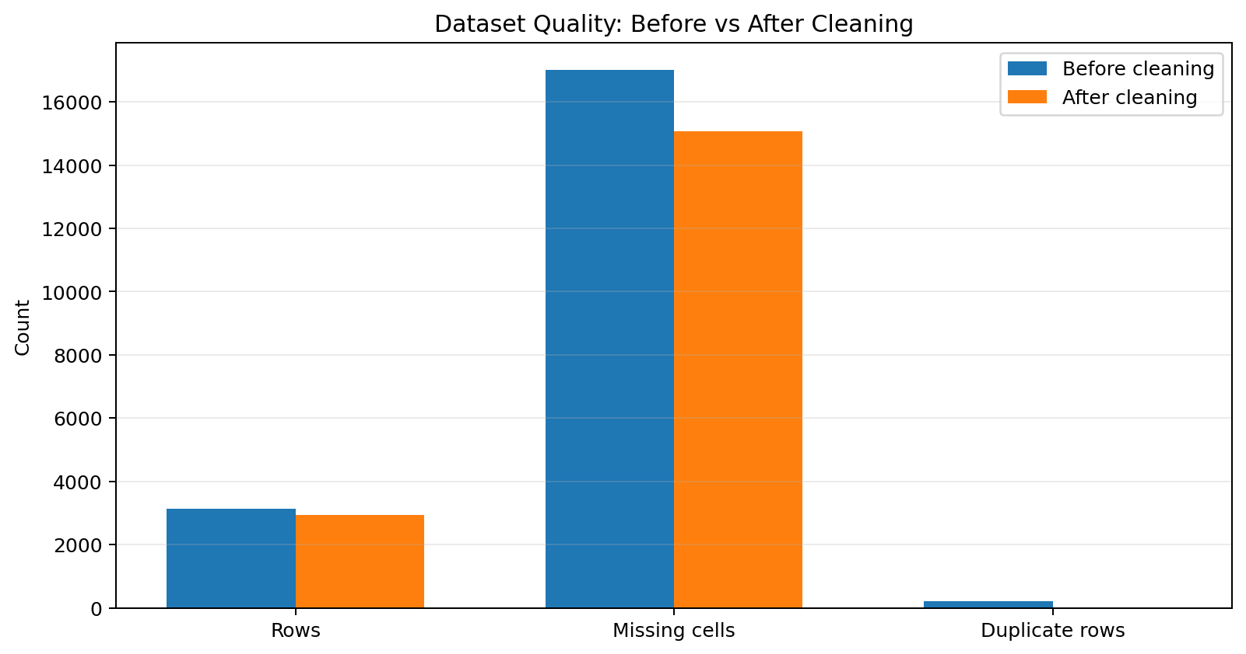
Figure 1. Direct comparison of major dataset-quality indicators.

3. Cleaning Process and Rationale

3.1 Initial inspection
The Week 3 cleaning notebook first loads the Ames Housing data and checks the dataset dimensions, data types, and initial records. This establishes a baseline before any cleaning decisions are made.

3.2 Missing-value assessment
Missing values were examined using both counts and percentages. This is important because a missing value in the Ames dataset does not always represent an error. In several categorical fields, a missing entry can indicate that the property does not have that feature.
- Examples include Pool QC, Fence, Alley, Fireplace Qu, Garage Type, and basement-related fields.
- For categorical fields representing absence of a feature, the notebook uses 'None' rather than treating the value as an unknown entry.
- For remaining numerical gaps, the notebook describes median imputation as a final exploratory-project strategy.
- For remaining categorical gaps, the notebook uses the mode when a value is still missing.
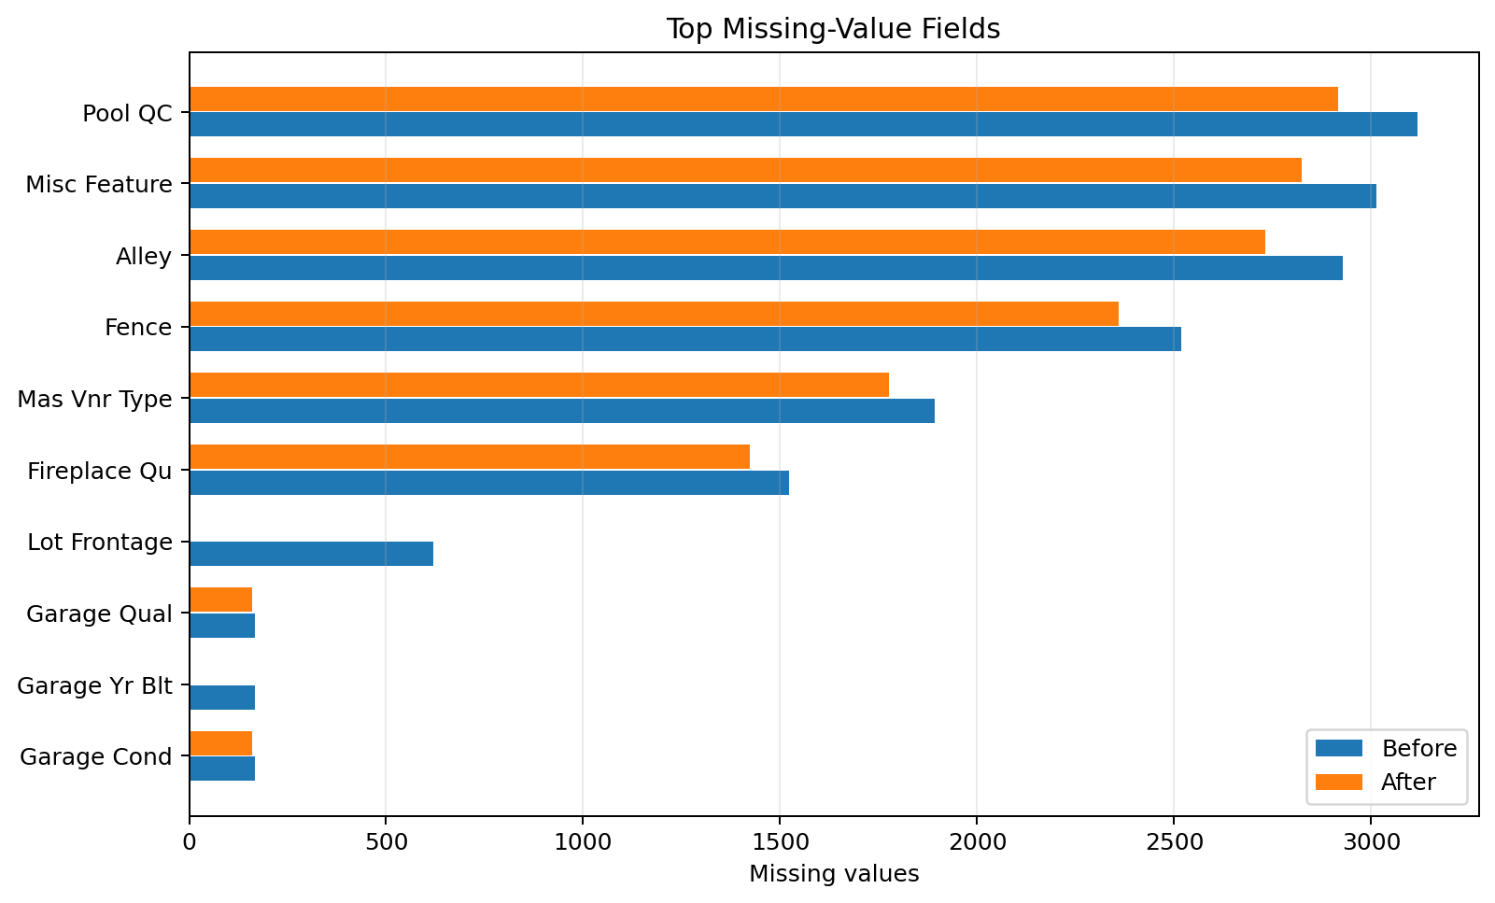
Figure 2. The largest missing-value fields before and after cleaning.

3.3 Most affected fields
Column | Missing before | Missing after | Reduction
Pool QC | 3,117 | 2,917 | 200
Misc Feature | 3,012 | 2,824 | 188
Alley | 2,927 | 2,732 | 195
Fence | 2,517 | 2,358 | 159
Mas Vnr Type | 1,892 | 1,775 | 117
Fireplace Qu | 1,523 | 1,422 | 101
Lot Frontage | 619 | 0 | 619
Garage Qual | 167 | 159 | 8

3.4 Duplicate rows
The original file contains 200 exact duplicate rows, while the supplied cleaned CSV contains 0. The direct comparison therefore indicates that 200 duplicate records were removed. This reduces repeated observations and prevents them from receiving unintended extra weight in later analysis.

3.5 Outlier screening
The cleaning notebook uses boxplots to visually inspect variables such as SalePrice, Gr Liv Area, Total Bsmt SF, 1st Flr SF, Garage Area, and Overall Qual. It also uses a Z-score threshold of |Z| > 3 as a screening rule. Importantly, the notebook states that a statistical outlier is not automatically a data error, so extreme observations are inspected rather than deleted solely because they are unusual.
Variable | Potential outliers before | Potential outliers after | Difference
SalePrice | 48 | 45 | 3
Gr Liv Area | 27 | 25 | 2
Total Bsmt SF | 22 | 21 | 1
1st Flr SF | 31 | 29 | 2
Garage Area | 17 | 17 | 0
The Z-score counts are presented as screening results, not proof that the corresponding records are incorrect. The cleaning notebook explicitly keeps potential outliers unless there is clear evidence of an invalid value.

4. Descriptive Comparison
Variable | Mean  Before | Mean  After | Median  Before | Median  After | Min  Before | Min  After | Max  Before | Max  After
SalePrice | 180,758.06 | 180,796.06 | 160,000.00 | 160,000.00 | 12,789 | 12,789 | 755,000 | 755,000
Gr Liv Area | 1,498.79 | 1,499.69 | 1,442.00 | 1,442.00 | 334 | 334 | 5,642 | 5,642
Overall Qual | 6.10 | 6.09 | 6.00 | 6.00 | 1 | 1 | 10 | 10
Year Built | 1,971.41 | 1,971.36 | 1,973.00 | 1,973.00 | 1,872 | 1,872 | 2,010 | 2,010
Total Bsmt SF | 1,053.41 | 1,051.26 | 991.00 | 990.00 | 0 | 0 | 6,110 | 6,110
Garage Area | 472.72 | 472.66 | 480.00 | 480.00 | 0 | 0 | 1,488 | 1,488
The descriptive statistics show that the overall numerical profile remains broadly similar after cleaning. For example, the median SalePrice remains $160,000 before and after cleaning, while the mean changes only slightly from approximately $180,758 to $180,796. This suggests that the cleaning did not radically alter the central tendency of the main numerical variables.
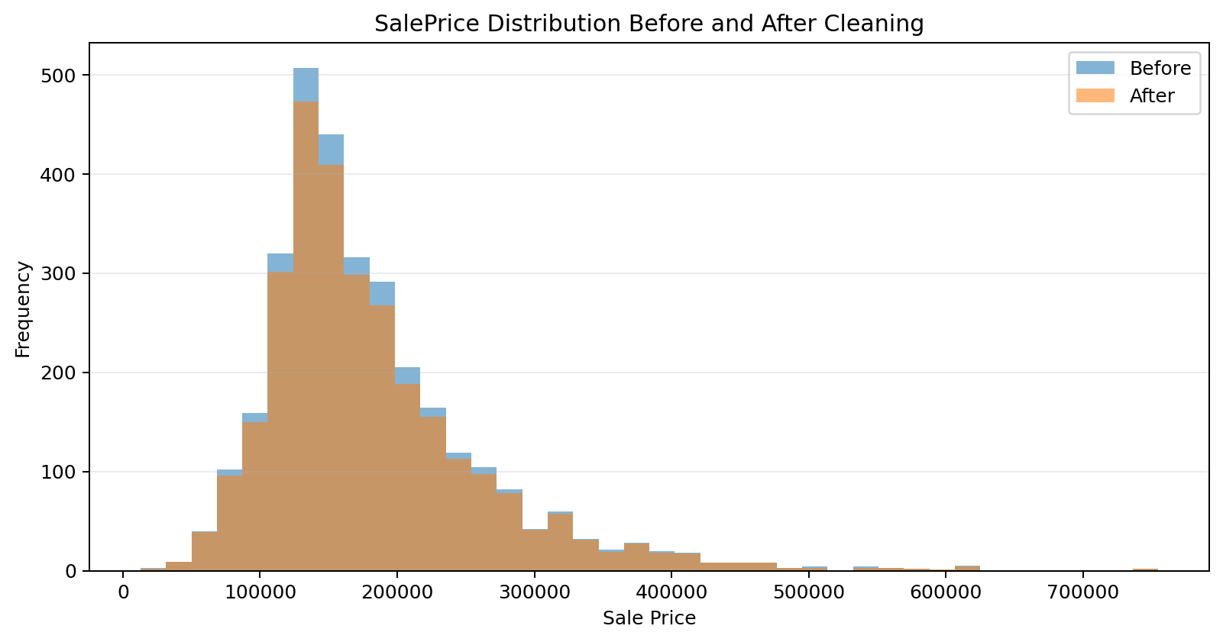
Figure 3. SalePrice distribution before and after cleaning.
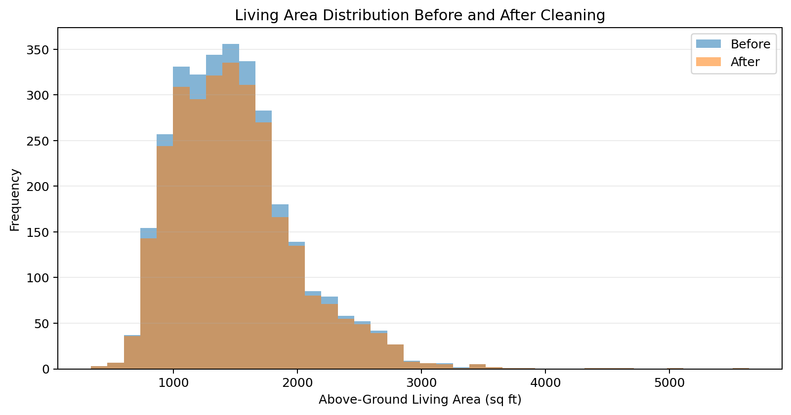
Figure 4. Above-ground living-area distribution before and after cleaning.

5. Readiness for Further EDA
The cleaned dataset is a better starting point for the next analysis stage because duplicate records have been removed and the number of missing cells has been reduced. The main relationships planned for EDA include SalePrice versus Overall Qual, Gr Liv Area versus SalePrice, correlations among numerical variables, average SalePrice by Neighborhood, construction-year distribution, living-area distribution, and SalePrice by House Style.
- SalePrice remains right-skewed, with a smaller number of high-priced properties.
- Overall Qual is expected to show a strong relationship with SalePrice.
- Gr Liv Area generally has a positive relationship with SalePrice.
- Neighborhood-level average prices can reveal meaningful location differences.
- Outliers should continue to be interpreted in context rather than automatically removed.

6. Data Consistency Note
The supplied Week 3 cleaning notebook and the supplied cleaned CSV are not identical in their observable final state. The notebook describes a workflow that checks missing values, applies categorical/absence handling, uses median/mode imputation for remaining gaps, and keeps potential outliers unless clearly invalid. However, the supplied cleaned CSV still contains 15,066 missing cells. It also contains 2,930 rows compared with 3,130 rows in the original file, with 200 exact duplicates removed. Because the report is based on the actual supplied before-and-after files, these figures are reported as they appear rather than being silently reconciled with the notebook's intended workflow.
For submission, it would be best to make the final cleaned CSV and the Week 3 notebook agree on the exact cleaning steps and final row/missing-value counts. This avoids a reviewer seeing one result in the notebook and a different result in the saved dataset.

7. Conclusion
Week 3 established a cleaner and more controlled version of the Ames Housing dataset for exploratory analysis. The main improvements visible in the supplied cleaned file are the removal of 200 duplicate rows and a reduction of 1,944 missing cells. The dataset retains all 82 columns, while the core numerical distributions remain broadly comparable before and after cleaning. Outlier screening has been treated as an investigative step rather than an automatic deletion rule, which is appropriate for a housing dataset where extreme values can represent genuine properties.
The cleaned dataset can therefore serve as the basis for the next stage of visualization and relationship analysis, provided the notebook and final CSV are aligned before submission.

